Homeostasis and Disruption to Homeostasis Test 2014

Name____________________________________________________

|  |  |  |
| --- | --- | --- |
| Test part | Possible mark | Your mark |
| Multiple choice | 10 |  |
| Short answer | 46 |  |
| Total | 56 |  |

***Multiple choice answer sheet.***

**Use a ball point or ink pen to mark an X** on the letter that represents the best answer from the choice of answers . Marks are not deducted for wrong answers.

|  |  |
| --- | --- |
| Question | Answer |
| 1 | A B C D |
| 2 | A B C D |
| 3 | A B C D |
| 4 | A B C D |
| 5 | A B C D |
| 6 | A B C D |
| 7 | A B C D |
| 8 | A B C D |
| 9 | A B C D |
| 10 | A B C D |

Section A Multiple Choice

1. Vasodilation of blood vessels near the skin will occur when:

a. the core body temperature is too high.

b. the core body temperature is too low.

c. the atmospheric temperature is too low.

d. the blood glucose level is too high.

2. The target organ/ tissue of progesterone is:

a. The endometrium.

b. The thyroid.

c. The ovaries.

d. The pancreas.

3. Dynamic equilibrium is best described as :

1. Unchanging and ideal conditions.
2. Maintenance of conditions within an acceptable range of limits. Some fluctuation occurs, but conditions remain within the limits.

c. Maintenance of conditions beyond an acceptable range of limits. Some fluctuation occurs, but conditions remain within the limits.

d. Maintenance of conditions within an acceptable range of limits. no fluctuation of conditions occurs.

1. The corpus luteum can be described as which of the following?
2. A temporary exocrine gland producing follicle stimulating hormone.
3. A temporary endocrine gland producing follicle stimulating hormone
4. A temporary exocrine gland producing oestrogen only.
5. A temporary endocrine gland producing oestrogen and progesterone.

5. Homeostasis is the

(a ) lowering of body temperature by sweating.

(b) secretion of hormones from endocrine glands.

(c) excretion of nitrogenous wastes in urine.

(d) maintenance of a constant internal environment.

6. Hypothyroidism

(a) is a result of an overactive thyroid gland.

(b) results in an enlarged thyroid gland.

(c) would be treated by the surgical removal of part of the thyroid.

(d ) results in fatigue and weight gain.

7. How is the control of cardiac muscle unique?

(a) It is not affected by the action of hormones.

(b) It can initiate its own contractions.

(c) It only involves nervous control.

(d) It is controlled by adrenalin.

8. The functional unit of the kidney is the:

(a) neuron.

(b) nephron.

(c) neutron.

(d) axon

9. Thermorecptors are located in the

a. abdominal organs

b. hypothalamus.

c. skin.

d. all of the above

10. Consumption of alcohol will:

a. increase urine volume and decrease urine concentration.

b. increase urine concentration and decrease urine volume.

c. decrease urine volume and decrease urine concentration.

d. will have no impact on kidney function.

Section B

1. The pancreas, an organ about the size of a hand, is located behind the lower part of the stomach. It makes hormones and enzymes that help the body digest and use food. Throughout the pancreas are clusters of cells called the islets of _______________________. Islets are made up of several types of cells, including beta cells that make ______________________.

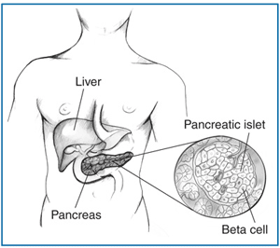  
Insulin is a hormone that helps the body convert ________________ to ____________________. This ___________________ can be stored in the ______________________. Insulin disruption can cause diseases. Complete the following passages about these diseases.

Type 1 ______________ develops when the body doesn't make enough insulin, causing _____________________ to build up in the blood. In type 1, due to an autoimmune disease-the beta cells of the pancreas no longer make insulin because the body's immune system has attacked and destroyed them. A person who has type 1 must inject ________________ daily to live.

Type 2 _______________ usually begins with a condition called ______________ resistance, in which the body has difficulty using insulin effectively. Over time, insulin production declines as well, so many people with type 2 diabetes eventually need to take insulin. Type 2 is called a __________________ disease because the chance of a person developing it increases as a result of poor lifestyle choices. There are certain risk factors which increase the chances of developing type 2 . List them here.

_________________________________________________________________________________________________________________________________________________________________________________________________

Islets of _________________ also contain alpha cells. These alpha cells release _________________. The function of this hormone is to convert __________________ to _________________. This increases the body’s blood ____________________ levels.

(20 marks)

1. Draw the negative feedback loop for a person who has started to exercise and has an increasing core body temperature.

(5 marks)

**Question 3. (8 marks)**

WA paramedics are about to take part in a national study to see if injecting heart attack patients with chilled saline solution improves their chances of survival. Scientists are conducting the study on 2500 patients in WA, South Australia and Victoria over the next three years. In the preliminary trial conducted over 3 months, some heart attack patients on their way to hospital in an ambulance were given intravenous cooling fluids to lower their core body temperature by about four degrees to 33oC and their survival rates were recorded. Other heart attack patients were treated by the current method. That is, taken to emergency departments where they were resuscitated until their pulse returned, before being given the cooled saline solution.

(a) What would be the independent variable? (1 mark)

_____________________________________________________________________

(b) Name two variables that should be controlled in the preliminary trial. (2 marks)

_____________________________________________________________________

_____________________________________________________________________

The preliminary trial data for 50 subjects is shown in the table below.

|  |  |  |  |  |  |
| --- | --- | --- | --- | --- | --- |
|  | Time elapsed before cold saline is injected (mins) | | | | |
| 1 | 5 | 10 | 30 | 50 |
| Number of subjects | 1 | 13 | 15 | 17 | 4 |
| Average chance of survival  (%) | 100 | 70 | 60 | 25 | 5 |

© Graph the results from the table on the grid provided on the next page to show the effect of injecting cooled saline at different times on one’s chance of survival. There is a spare grid at the end of the answer booklet if you want to redraw this graph. Please indicate if you are going to use it. (5 marks)

|  |  |  |  |  |  |  |  |  |  |  |  |  |  |  |  |  |  |  |  |  |  |  |  |  |
| --- | --- | --- | --- | --- | --- | --- | --- | --- | --- | --- | --- | --- | --- | --- | --- | --- | --- | --- | --- | --- | --- | --- | --- | --- |
|  |  |  |  |  |  |  |  |  |  |  |  |  |  |  |  |  |  |  |  |  |  |  |  |  |
|  |  |  |  |  |  |  |  |  |  |  |  |  |  |  |  |  |  |  |  |  |  |  |  |  |
|  |  |  |  |  |  |  |  |  |  |  |  |  |  |  |  |  |  |  |  |  |  |  |  |  |
|  |  |  |  |  |  |  |  |  |  |  |  |  |  |  |  |  |  |  |  |  |  |  |  |  |
|  |  |  |  |  |  |  |  |  |  |  |  |  |  |  |  |  |  |  |  |  |  |  |  |  |
|  |  |  |  |  |  |  |  |  |  |  |  |  |  |  |  |  |  |  |  |  |  |  |  |  |
|  |  |  |  |  |  |  |  |  |  |  |  |  |  |  |  |  |  |  |  |  |  |  |  |  |
|  |  |  |  |  |  |  |  |  |  |  |  |  |  |  |  |  |  |  |  |  |  |  |  |  |
|  |  |  |  |  |  |  |  |  |  |  |  |  |  |  |  |  |  |  |  |  |  |  |  |  |
|  |  |  |  |  |  |  |  |  |  |  |  |  |  |  |  |  |  |  |  |  |  |  |  |  |
|  |  |  |  |  |  |  |  |  |  |  |  |  |  |  |  |  |  |  |  |  |  |  |  |  |
|  |  |  |  |  |  |  |  |  |  |  |  |  |  |  |  |  |  |  |  |  |  |  |  |  |
|  |  |  |  |  |  |  |  |  |  |  |  |  |  |  |  |  |  |  |  |  |  |  |  |  |
|  |  |  |  |  |  |  |  |  |  |  |  |  |  |  |  |  |  |  |  |  |  |  |  |  |
|  |  |  |  |  |  |  |  |  |  |  |  |  |  |  |  |  |  |  |  |  |  |  |  |  |
|  |  |  |  |  |  |  |  |  |  |  |  |  |  |  |  |  |  |  |  |  |  |  |  |  |
|  |  |  |  |  |  |  |  |  |  |  |  |  |  |  |  |  |  |  |  |  |  |  |  |  |
|  |  |  |  |  |  |  |  |  |  |  |  |  |  |  |  |  |  |  |  |  |  |  |  |  |
|  |  |  |  |  |  |  |  |  |  |  |  |  |  |  |  |  |  |  |  |  |  |  |  |  |
|  |  |  |  |  |  |  |  |  |  |  |  |  |  |  |  |  |  |  |  |  |  |  |  |  |
|  |  |  |  |  |  |  |  |  |  |  |  |  |  |  |  |  |  |  |  |  |  |  |  |  |
|  |  |  |  |  |  |  |  |  |  |  |  |  |  |  |  |  |  |  |  |  |  |  |  |  |
|  |  |  |  |  |  |  |  |  |  |  |  |  |  |  |  |  |  |  |  |  |  |  |  |  |
|  |  |  |  |  |  |  |  |  |  |  |  |  |  |  |  |  |  |  |  |  |  |  |  |  |
|  |  |  |  |  |  |  |  |  |  |  |  |  |  |  |  |  |  |  |  |  |  |  |  |  |

4 (a). Look at this diagram and complete the table and questions that follow it.

[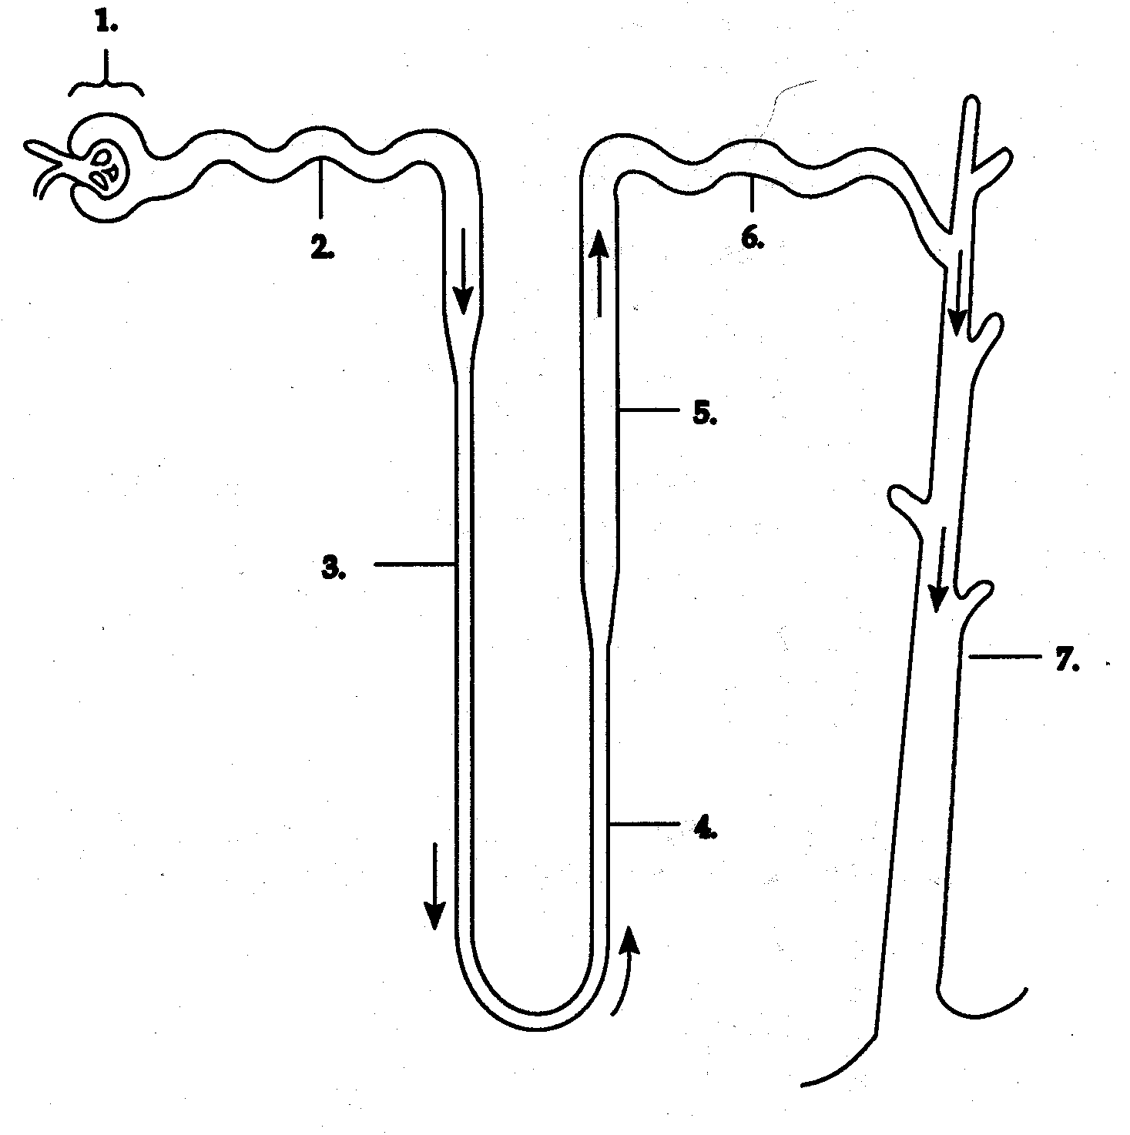](http://www.google.com.au/url?sa=i&rct=j&q=nephorn%20diagram&source=images&cd=&cad=rja&uact=8&docid=xzAr9UJpUcf-aM&tbnid=1ZV4xpMyzczyrM:&ved=0CAUQjRw&url=http%3A%2F%2Fwww.snider.fwcs.k12.in.us%2Fapbiology%2Fhomework%2FUnit%252015%2Fchapter_44.htm&ei=-6HZU6CwDpOcugTZ3ILQBw&psig=AFQjCNGLW16qoXDvWkbG7SCXLkYsleO06Q&ust=1406858073457252)

|  |  |
| --- | --- |
| Number | Structure name |
| 1 |  |
| 2 |  |
| 3, 4 and 5 |  |
| 6 |  |

(4 marks)

Now use this diagram to answer the question on the following pages.

(b). The process that occurs in structure 1 requires high blood pressure. What is the name of this process and how is the pressure made high?

______________________________________________________________________________________________________________________________________________________________________________________________________________________________________________________________________________________________________________________________________________________________________________________________________________________________

(3 marks)

(c). This structure is located in the kidney. Why does it contribute to the kidney having a high energy requirement?

____________________________________________________________________________________________________________________________________________________________________________________________________________________________________________________________________________________

(2 marks)

1. Explain the impact caffeine has on the concentration and volume of urine? State the reason for this.

___________________________________________________________________________________________________________________________________________________________________________________________________________________________________________________________________________________

(4 marks)

**End of Test**

Spare Grid

|  |  |  |  |  |  |  |  |  |  |  |  |  |  |  |  |  |  |  |  |  |  |  |  |  |
| --- | --- | --- | --- | --- | --- | --- | --- | --- | --- | --- | --- | --- | --- | --- | --- | --- | --- | --- | --- | --- | --- | --- | --- | --- |
|  |  |  |  |  |  |  |  |  |  |  |  |  |  |  |  |  |  |  |  |  |  |  |  |  |
|  |  |  |  |  |  |  |  |  |  |  |  |  |  |  |  |  |  |  |  |  |  |  |  |  |
|  |  |  |  |  |  |  |  |  |  |  |  |  |  |  |  |  |  |  |  |  |  |  |  |  |
|  |  |  |  |  |  |  |  |  |  |  |  |  |  |  |  |  |  |  |  |  |  |  |  |  |
|  |  |  |  |  |  |  |  |  |  |  |  |  |  |  |  |  |  |  |  |  |  |  |  |  |
|  |  |  |  |  |  |  |  |  |  |  |  |  |  |  |  |  |  |  |  |  |  |  |  |  |
|  |  |  |  |  |  |  |  |  |  |  |  |  |  |  |  |  |  |  |  |  |  |  |  |  |
|  |  |  |  |  |  |  |  |  |  |  |  |  |  |  |  |  |  |  |  |  |  |  |  |  |
|  |  |  |  |  |  |  |  |  |  |  |  |  |  |  |  |  |  |  |  |  |  |  |  |  |
|  |  |  |  |  |  |  |  |  |  |  |  |  |  |  |  |  |  |  |  |  |  |  |  |  |
|  |  |  |  |  |  |  |  |  |  |  |  |  |  |  |  |  |  |  |  |  |  |  |  |  |
|  |  |  |  |  |  |  |  |  |  |  |  |  |  |  |  |  |  |  |  |  |  |  |  |  |
|  |  |  |  |  |  |  |  |  |  |  |  |  |  |  |  |  |  |  |  |  |  |  |  |  |
|  |  |  |  |  |  |  |  |  |  |  |  |  |  |  |  |  |  |  |  |  |  |  |  |  |
|  |  |  |  |  |  |  |  |  |  |  |  |  |  |  |  |  |  |  |  |  |  |  |  |  |
|  |  |  |  |  |  |  |  |  |  |  |  |  |  |  |  |  |  |  |  |  |  |  |  |  |
|  |  |  |  |  |  |  |  |  |  |  |  |  |  |  |  |  |  |  |  |  |  |  |  |  |